Lab Objective

Configuring NAP Enforcement for DHCP

**Lab Procedures**

**1.** On RWDC01, right-click the Start button, and select Command Prompt (Admin).

**2.** At the command prompt, execute the **napclcfg.msc** command. The NAP Client Configuration console opens, as shown in Figure 14-1.

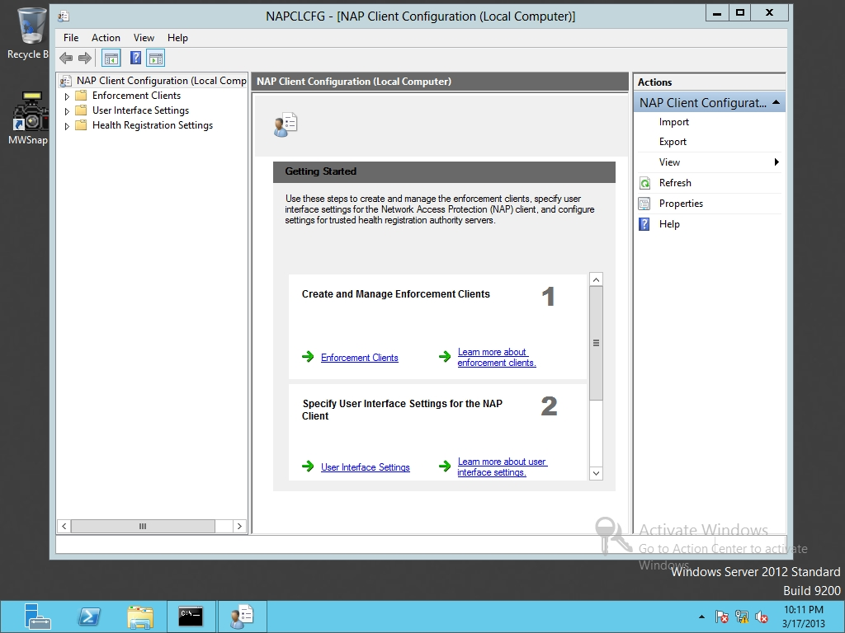

Figure 14-1

Opening the NAP Client Configuration

**3.** In the left pane, click Enforcement Clients.

**4.** In the center pane, double-click DHCP Quarantine Enforcement Client to open the DHCP Quarantine Enforcement Client Properties dialog box.

**5.** Select the Enable this enforcement client option. Click OK to close the DHCP Quarantine Enforcement Client Properties dialog box.

**6.** Take a screen shot of the NAP Client Configuration window by pressing Alt+Prt Scr and then paste it into your Lab14_worksheet file in the page provided by pressing Ctrl+V.

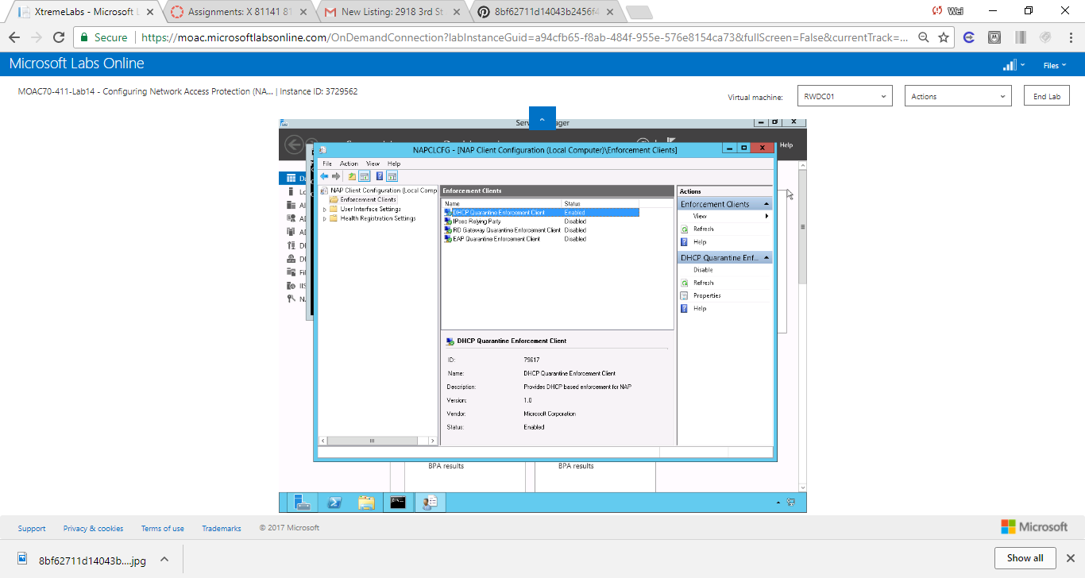

Figure Screenshot shows NAP Client Configuration window

**7.** Close the NAP Client Configuration Client console.

**8.** At the command prompt, execute the **services.msc** command.

**9.** Scroll down and find the Network Access Protection Agent. Then double-click the Network Access Protection Agent service to open the Network Access Protection Agent Properties dialog box.

**10.** Change the Startup type to Automatic.

**11.** Take a screen shot of the Network Access Protection Agent Properties dialog box by pressing Alt+Prt Scr and then paste it into your Lab14_worksheet file in the page provided by pressing Ctrl+V.

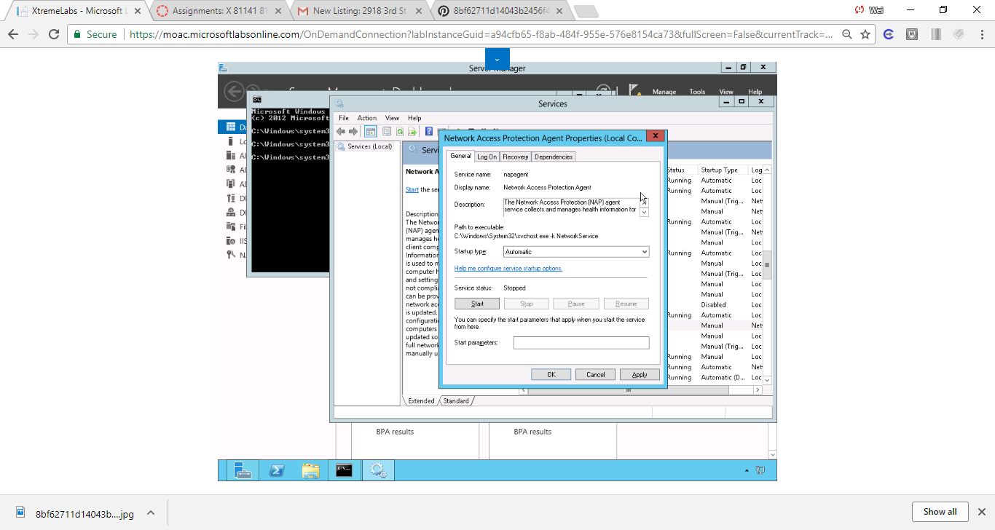

Figure Screenshot shows the Startup type is set to Automatic.

**12.** Click the Start button.

**13.** After the service is started, click OK to close the Network Access Protection Agent Properties dialog box.

**14.** Close the Services console and close the command prompt.

**15.** Using Server Manager, open the Tools menu and click Network Policy Server. The Network Policy Server console opens.

**16.** In the main pane, click Configure NAP to start the Configure NAP Wizard (as shown in Figure 14-2).

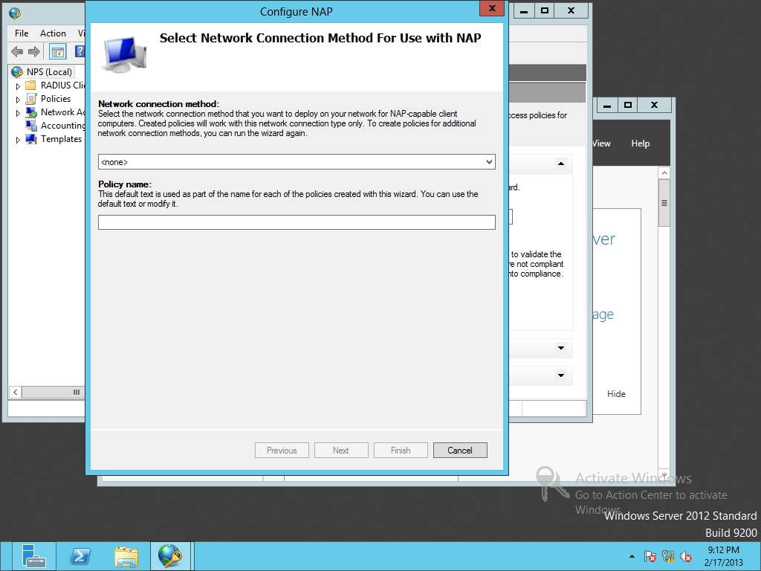

Figure 14-2

Configuring NAP

**17.** When the Select Network Connection Method For Use with NAP Wizard opens, select the Dynamic Host Configuration Protocol (DHCP) for the network connection method from the drop-down list. Click Next.

**18.** On the Specify NAP Enforcement Servers Running DHCP Server page, because Server01 is already running DHCP, click Next.

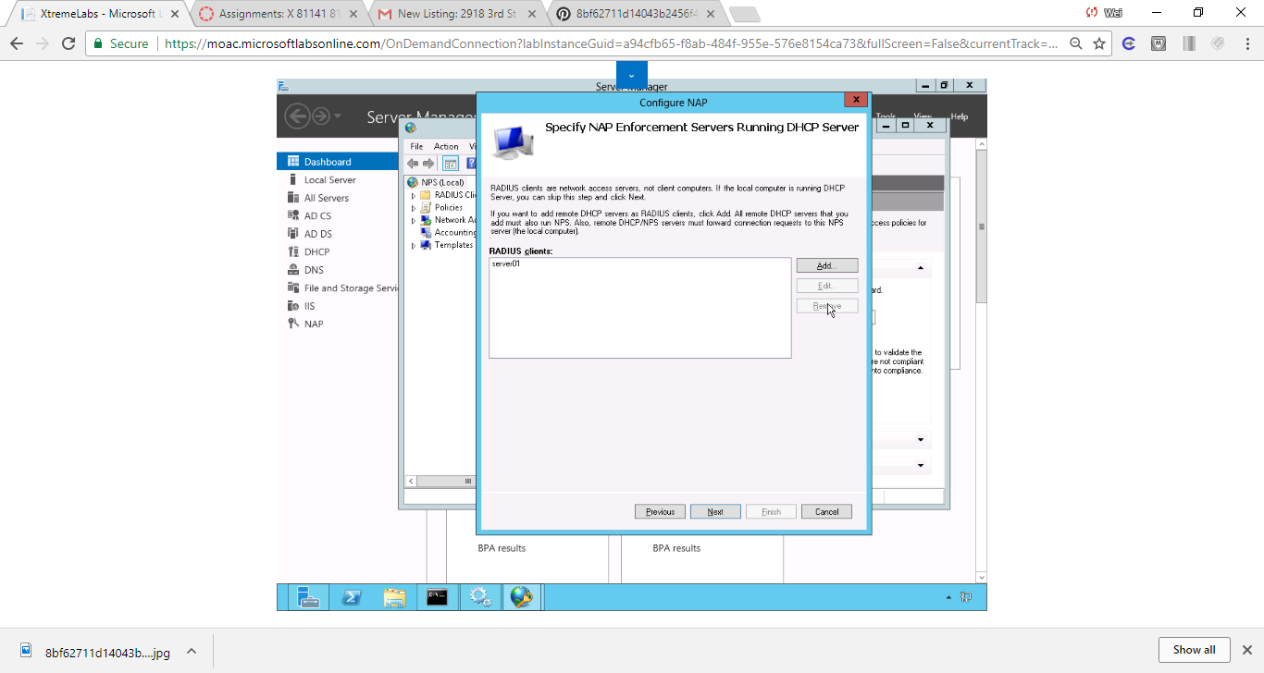

Figure Screenshot shows On the Specify NAP Enforcement Servers Running DHCP Server page, because Server01 is already running DHCP, click Next.

**19.** On the Specify DHCP Scopes page, click the Addbutton to open the MS-Server Class page (as shown in Figure 14-3). Type **NAP DHCP** in the text box and click OK. On the Specify DHCP Scopes page, click Next.

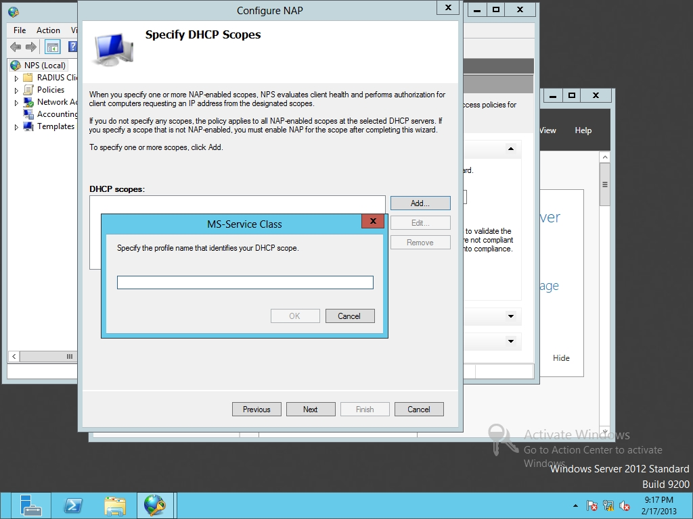

Figure 14-3

Configure the MS-Service Class

**20.** On the Configure Machine Groups page, click the Add button to open the Select Group dialog box. In the Enter the object name to select text box, type **domain computers** and click OK. Click Next.

**21.** On the Specify a NAP Remediation Server Group and URL page (as shown in Figure 14-4), click New Group. In the Group Name text box, type **Remediation Servers**.

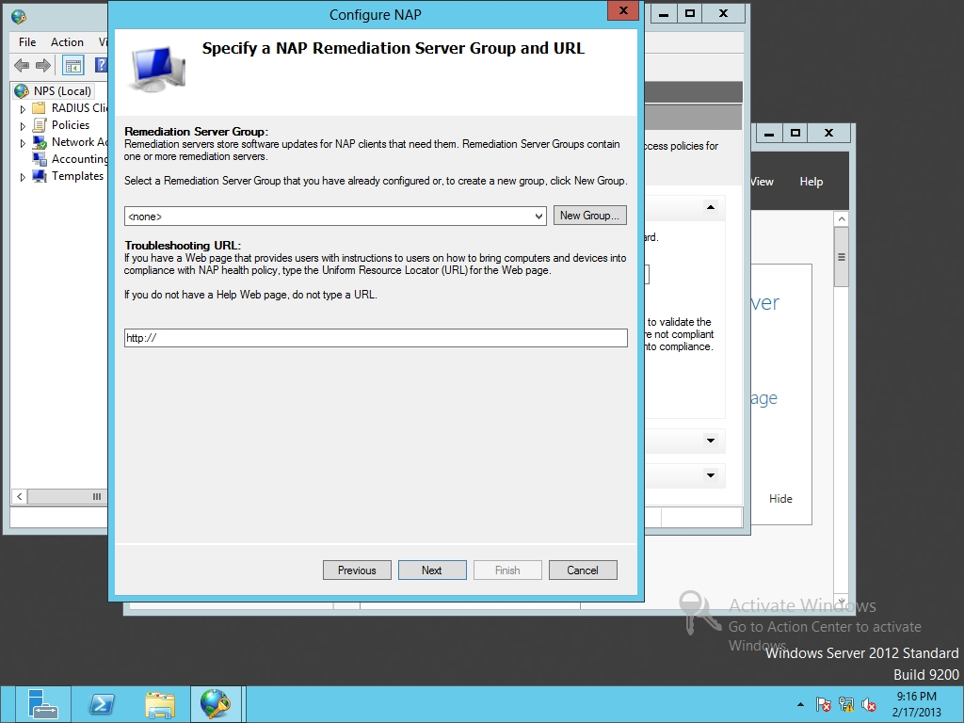

Figure 14-4

Specifying the NAP remediation server group and URL

**22.** Click the Add button. In the Friendly name text box, type **Server01**. For the IP address or DNS name, type **Server01.contoso.com** and click Resolve. Click OK to close the Add New Server and click OK to close the New Remediation Server Group dialog box. Click Next.

**23.** On the Define NAP Health Policy page, click Next.

**24.** On the Completing NAP Enforcement Policy and RADIUS Client Configuration page, click Finish.

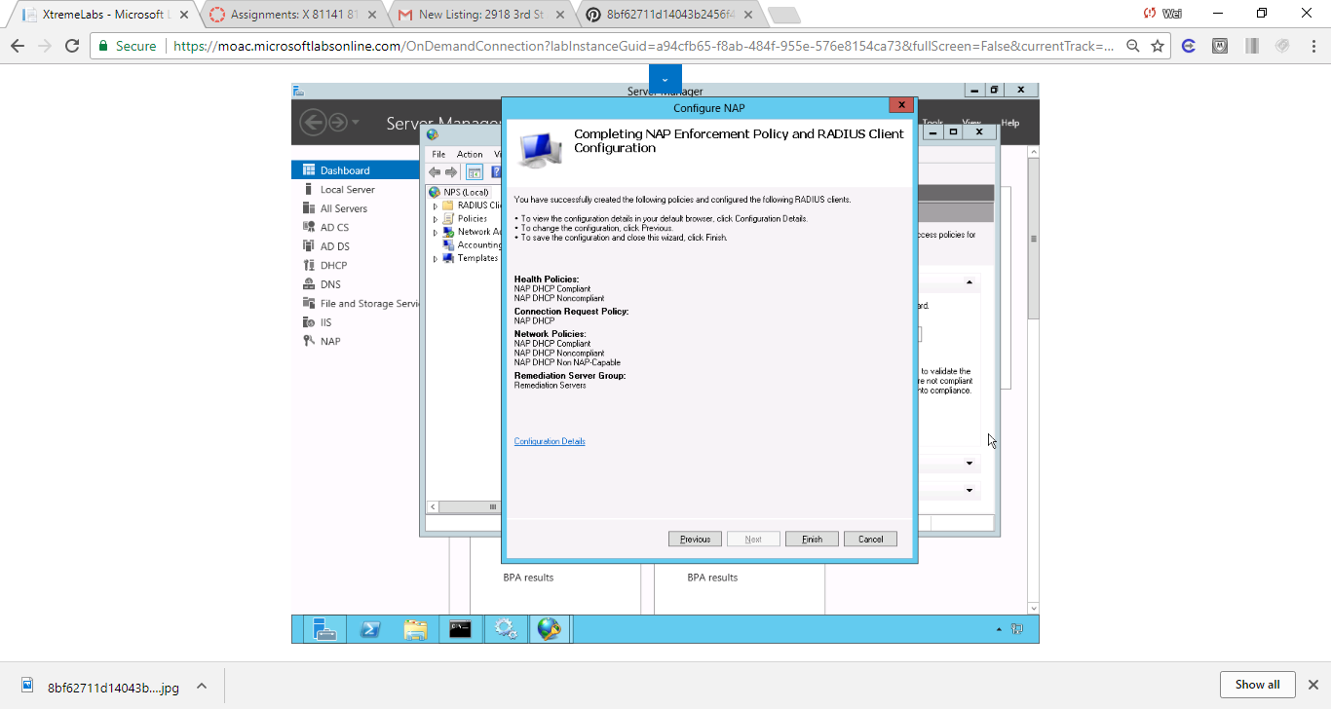

Figure On the Completing NAP Enforcement Policy and RADIUS Client Configuration page, click Finish.

**25.** Using Server Manager, open the Tools menu and click DHCP. The DHCP console opens.

**26.** Expand the server node and expand the IPv4node.

**27.** Click Scope [192.168.1.0]. Then right-click Scope [192.168.1.0] and click Properties. A Scope Properties dialog box opens.

**28.** Click the Network Access Protection tab, as shown in Figure 14-5.

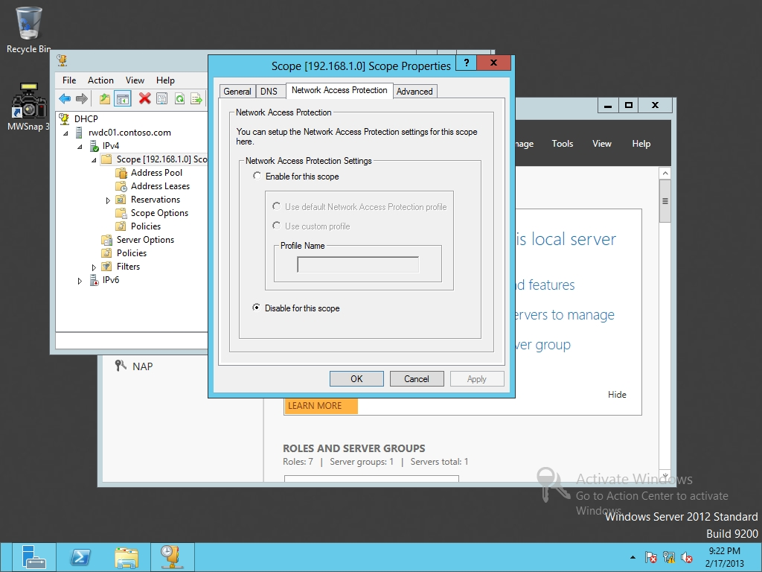

Figure 14-5

Enabling Network Access Protection

**29.** Click Enable for this scope.

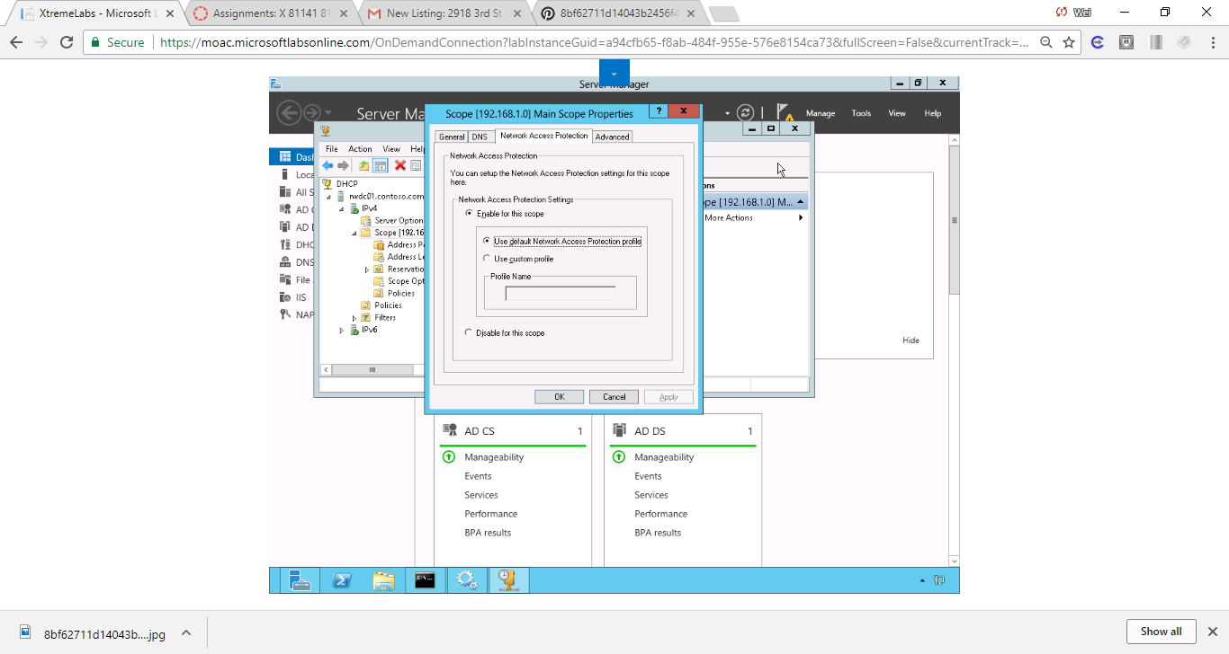

Figure Click the Network Access Protection tab and enable for this scope

**30.** Click OK to close Scope Properties dialog box.

**31.** Close DHCP console.

End of exercise.

**Lab Summary**

During this exercise, I configured NAP enforcement for DHCP, specified the remediation servers, and enabled NAP for a DHCP scope. Remediation server groups are used to specify servers that are available to noncompliant Network Access Protection (NAP) clients for the purpose of remediating their health state to comply with health requirements. Antivirus management servers and Windows update servers are the basic redediation servers I should include.